Anderson Junior College
Preliminary Examination 2012
H2 Mathematics Paper 1 (9740/01)

1 The sum of the first 100 terms of an arithmetic progression is 10,000. The first, second and fifth terms of this progression are three consecutive terms of a geometric progression. Find the first term and the non-zero common difference of the arithmetic progression. [5]

2 The equation of a curve is 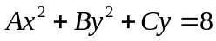, where A, B and C are constants. The curve has a tangent parallel to the y-axis at the point (2,1). Given that 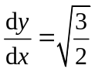 and 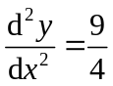 at the point where the curve cuts the positive x-axis, find the values of A, B and C. [6]

3 Without using a calculator, solve the inequality 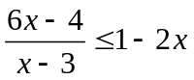, 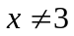. [4]
Hence find the exact range of values of for which 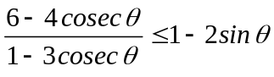 where 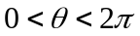. [3]

4 A curve with equation y = f(x) is transformed by a reflection in the y-axis, followed by a translation of 1 unit in the negative x-axis, followed by a scaling with factor 2 parallel to the y-axis.
The equation of the resulting curve is given by y = g(x), where
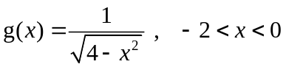.
- Find f(x). [3]
- On the same diagram, sketch the graph of y = g(x) and y = g⁻¹(x). [3]
- Without evaluating g⁻¹(x), find the exact area of the region bounded by the curve y = g⁻¹(x), the x-axis and the line x = 1. [4]

5 Consider 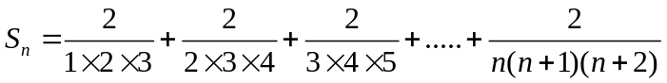
(i) Calculate the values of 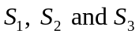. [2]
(ii) Make a conjecture for  in the form 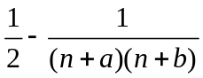, where a and b are integers. [1]
(iii) Prove your conjecture by the method of induction. [5]

6
R
l
2
r

The diagram shows a right circular cone of height of 2 units, radius r and slant height l inscribed in a sphere of radius R.
  - Show that 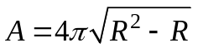, where A is the curved surface area of the cone. [3]
  - If the volume of the sphere is increasing at a rate of 8 units³/sec, find the exact rate of change of A at the instant when R = 2 units. [4]

[Curved surface area of a right circular cone with base radius r and slant height l is 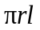. Volume of sphere = 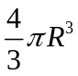 where R is the radius of the sphere.]

7 A sequence of numbers, 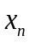, satisfy the relation
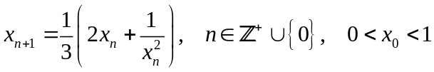.
(i) If the sequence converges to a number L, find L. [2]
(ii) Given that 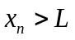 for all integers 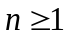, show that 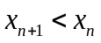. [3]
(iii) Describe, with reference to (i) and (ii), the behaviour of the sequence. [1]
The difference 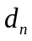 between and L is given by 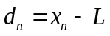. Show that 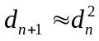 and state the range of values of for which this approximation is valid. [4]

8 (a) The diagram below shows a region R bounded by the curve 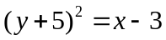 and the line 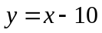. Find the volume of solid formed when R is rotated through four right angles about the x-axis. [4]
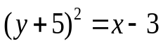
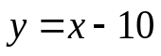
y
0
x
R

(b) (i) Show that 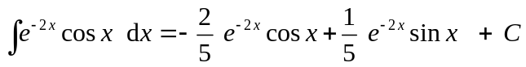 ,
where C is an arbitrary constant. [4]

(ii) A curve Γ is defined by the parametric equations
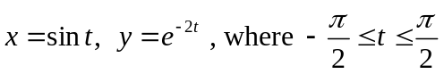.
Find the exact area of the region bounded by the curve Γ, the tangent to the curve Γ at the y-axis and the line . [5]

9 The curve C has equation 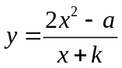 where 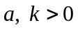.
(i) Given that 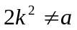, find the range of values of such that the curve C has at least one tangent parallel to the -axis. [4]
(ii) What can be said about the graph of when 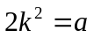? [2]

For the range of values of in (i),
(iii) sketch the curve of C, clearly indicating the equations of the asymptotes and any intercepts with the axis. [3]
(iv) The curve does not intersect the curve 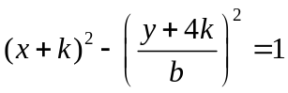 where b > 0. By drawing the 2 curves on the same diagram, find the range of values of . [2]

10 The two planes p₁ and p₂, given by the equations 2x + y = 1 and 8x +ay + z =4 respectively, meet at a line L which contains the point A(0,1,0).
(i) Show that a = 4 and hence find the vector equation of the line L. [3]
(ii) Another point B lies in the plane p₁ such that AB is perpendicular to the line L. Show that 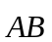 is parallel to 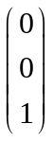.
If the distance of B from p₂ is 5 units, find the possible position vectors of point B. [5]

(iii) Find the acute angle between line AB and p_{2.} [2]

(iv) A third distinct plane p₃ is given by the equation 2x+ y +βz = 6. Show that p₁, p₂ and p₃ do not meet at a common point for all values of β. Comment on the geometrical relationship of the three planes when β = 0. [3]

11 The point A represents the complex number a with |a| = 1 and 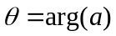, 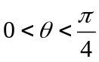. The point B represents the complex number ia.

The complex number z satisfies the relations
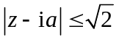 and 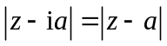.

Sketch clearly, on a single Argand diagram, the locus of the point representing the complex number , with reference to the points A and B. Find the angle that the locus of z makes with the positive real axis in terms of . [4]

By writing 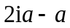 as 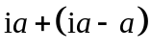, or otherwise, indicate the point C representing the complex number on your diagram and state the geometrical relationship between the points A, B and C. [2]

Hence find
- the least value of 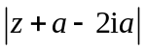, and [1]
- the largest value of 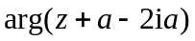. [3]

END OF PAPER

